Home Schooling Timetable Idea
Primary 3/4

Before 9am | Wake Up | 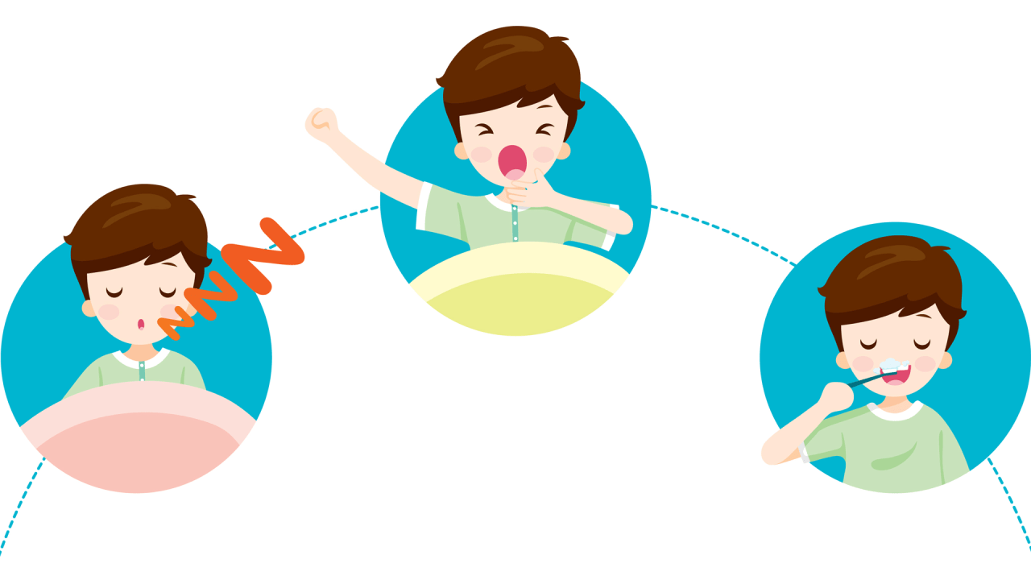 | - Have Breakfast  - Get dressed  - Brush your teeth  - Make your bed  - Tidy your room
9-10am | Exercise time |  | - If possible, a morning walk social distancing  - ‘Go Noodle’ movement breaks available on You tube  - Joe Wicks ‘The Body Coach’ daily workouts at 9am  - Dance with Oti Mabuse on Facebook every day at 11.30am but children can view the class at any time
10 -11am | Academic time/snack |  | No electronics –  - School work packs provided (Twinkl an excellent resource for print outs)  - Reading/sharing a book *
11 – 12pm | Creative Time |  | - Lego, drawing, colouring, craft activities, music, cooking/baking together  Music with Mylenne Klass on YouTube every Monday and Friday at 10am, but can be viewed any time.
12 – 1pm | Lunch/Relax |  | Controlled electronics  iPads/tablets, computers, consoles. Online safety information on school Facebook page.
1pm – 1.30pm | Exercise Time |  | Games in the garden, stretches etc.
1.30 – 2.30pm | Academic Time |  | No electronics –  - School work packs provided (Twinkl an excellent resource for print outs)  - Reading/sharing a book *
2.30 – 3.00pm | Quiet time |  | Relax with a book, watch a T.V. programme or play a board game etc.  Mindful Colouring – lots available on www.twinkl.co.uk

*Search The World of David Walliams Elevenses. Every day at 11am, you can listen to one of David Walliams’ World’s Worst Children stories for 20ish minutes or Reading materials can be found on: https://home.oxfordowl.co.uk/books/free-ebooks/

- Download ‘Teach your monster to read’ app – can be done for 15/30 minutes daily.
- Read the school reading books provided in pack.
- www.librariesni.org.uk e-books
Literacy ideas: Write a letter to someone in your family you can’t visit, make a set of instructions for making a sandwich/crispy buns, write your spellings in a tray using salt/rice, copy your spellings in rainbow colours/circle the vowels/write using upper and lower case letters/make a spelling flower with the letters on the petals/make a word worm with all your weekly words/write them forwards and backwards/write them with your opposite writing hand/with your eyes closed/place them into a sentence/find small words in the bigger words/use rhymes to help you remember them; e.g. Sa
Is
Ten
Keep a diary and record 3 positive things you have done each day. The list is endless……………….

Numeracy ideas:
Times tables treasure hunts around your house – find the answer to the times table fact……..printables can be found on Twinkl. Twinkl is usually a paid subscription site but in the light of recent events it has very kindly been made available free to everyone for one month by using the following code UKTWINKLHELPS
- Measuring around the home with a tape – greater than/less than a metre
- Finding 3-D shapes in the home
- Setting out groups of 2’s/5’s/10’s with household objects/counters/grains of rice
- Finding numbers around the house and ordering them from largest to smallest
- Telling the time at regular intervals during the day
- Using Topmarks website to play games we play in the classroom for mental maths:
- Toy Shop Money Game – giving change
- Hit the button – times tables
- Mental maths train
- Rocket rounding
- Calculation balance
Many more if you search the age group and subject.

- Problem solve – how many toilet rolls do we use in a week? How long will our supply last!
- Money – set up a tuck shop and price list – work on counting money and giving change

- http://snappymaths.com/ for mental maths tests and www.timestables.me.uk – to generate printable times tables tests
- The Maths Factor – www.themathsfactor.com Created by Carol Vorderman for children aged 4-12 years.

Most importantly, focus on making connections and feelings of safety within your child/children.

Take care
Mrs Paul

