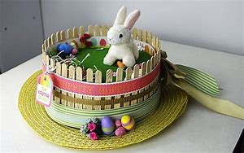
Easter Bonnets.
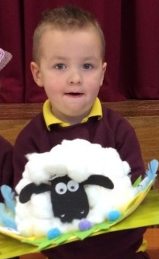
Thank you for all your hard work making and completing the Easter bonnets. They were wonderful!
Mrs Armstrong picked Kaden Thompson’s fantastic Sheep Hat as first place. Congratulations Kaden!


Important Dates for Diary
School closed 2nd May Election Day
School closed 3rd May Teacher Training
School closed 6th May Bank Holiday
Friday 24th May – Sports Day (weather permitting)
Monday 27th May School Closed – Bank Holiday
Tuesday 28th May – Exceptional Closure
Thursday 6th June – Trip to Gosford Forest Park
Friday 21st June Nursery Graduation at 9.30am
Friday 28th June Final Assembly at 9.30am.

Sports Day
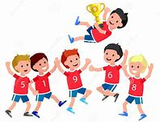
We hope Sports Day will be held on 24th May (weather permitting.) Starting at 9.30am, it will run up to approx. 11.30am. At the end of the races Nursery children will return to class for their medals and certificates. You are welcome to join us for the ceremony. The children can go home with you afterwards or they can stay to the end of the session.
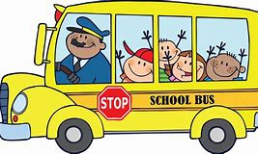
Trip to Gosford Forest Park
We have arranged an end of year class trip to ‘Gosford Forest Park’, Markethill, were we will be visiting both the animals and play park.
It will be held on Thursday 6th June 2019. We plan to leave school at 9.30am and return at 1.30pm. There will be a charge for this trip of

£5 per child. This is to cover the cost of the bus. Nursery will provide a snack and drink for mid-morning but each child will need to bring - a packed lunch and rain coat, in their school bag. If anyone is able to come and join us, your help would be very much appreciated. As we are using EA transport, we cannot take volunteers with us on the bus. You would need to meet us at the car park at approx. 10am.

Nursery Graduation.
This year we are holding a Graduation to celebrate the Nursery Children’s move from Nursery into Big School.

Friday 21st of June starting at 9.30am. Numbers are very limited, so each child will receive two tickets only, (due to catering arrangements.) We will have a short performance followed by juice/tea/coffee and a snack. There will be a photo booth for those who wish to partake.

Shorts and shades

May 17th is a Non-Uniform Day – Please come alone in your Shorts and Shades. Please bring along one pound.

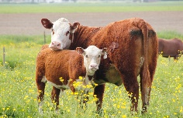
Next term we are looking at Animals both domestic and wild. You can help the children by talking about the different names used for Mothers and Babies such as cow and calf and
Keeping safe around the farm. Thanks

